Becker Dance Team Competition Insights Dashboard
Autumn Martin
Wilmington University - CSC489
November 30th, 2025

Table of Contents
1 Project Overview 4
2 Planning Phase 5
2.1 Scope 5
2.2 Business Process 5
2.3 Requirements 6
2.4 Use Case Scenario 7
2.5 Design Artifacts 7
2.6 Technical Workflow 8
2.7 Project Constraints 9
2.8 Methodology 9
2.9 GANNT Template 9
3 Analysis Phase 11
3.1 Roles and Responsibilities 11
3.2 Use Case Journey 14
3.3 Functional Requirements 15
3.4 Non-functional Requirements 17
3.5 Traceability Matrix 18
4 Design Phase 21
4.1 Technical Architecture 21
4.2 Entity Relationship Diagram 22
4.3 Data Dictionary 24
4.4 Use Case Alignment 27
4.5 Dashboard Structure 27
4.6 Wireframes 28
4.7 Design Alignment 30
4.8 Ethical Considerations 31
5 Development Phase 31
5.1 Set Up Process 31
5.2 Data Preparation 32
5.3 Cleaning and Updating 32
5.4 Average Score By Competition Views 33
5.5 Average Scores By Categories and Competition 35
5.6 Dashboard Development 40
5.7 Home Page 40
5.8 Jazz & Kick Overview Dashboards 41
5.8.1 Jazz & Kick Average Scores Bar Graphs 43
5.8.2 Jazz & Kick Average Scores By Categories Heat Maps 43
5.8.3 Jazz & Kick Tree Maps 44
5.8.4 Jazz & Kick Highest and Lowest Scoring Competitions KPI 45
5.9 Jazz & Kick Drill Down Dashboards 49
5.9.1 Jazz & Kick Average Scores By Competition Tables 50
5.9.2 Jazz & Kick Average Scores by Category and Competition 51
5.10 Technical Architecture and Software Quality 52
6 Testing Phase 53
6.1 Validate Use Case Journey 53
6.2 Traceability matrix 54
6.3 Testing Failures and Fixes 59
6.3.1 Test Case 3 & 4 – KPI Validation 59
6.3.2 Test Case 15 – Device Layouts 60
6.4 User Feedback 61
6.5 Professional Feedback 62
7 Implementing and Maintenance 64
7.1 Distributing The System 64
7.2 User Documentation 64
7.3 Training 66
7.4 Help Desk/ Support 66
7.5 Monitoring and System Changes 67
8 References 68

Project Overview
The goal of my dashboard project is to create an interactive Tableau dashboard that visualizes four years of high school dance team scores, broken down by average score across competition, style, and year. The dashboard will help coaches and dancers understand past performance, evaluate areas of strength and weakness, and celebrate improvements that might otherwise go unnoticed. Creating this dashboard allows for organized, visual storytelling of score data in a way that is both accessible and insightful (Mănescu, 2025). My Tableau dashboard will include filters to isolate specific scores and trends, supporting a clear narrative for users. This project reflects both my passion for coaching and my deep understanding of the dance team world.
To deliver this project successfully, I will follow the seven steps of the System Development Life Cycle (SDLC). From September 8th to 21st, during the planning phase, I will define the scope of the project and outline key objectives. From September 22nd to October 8th, during the analysis phase, I will sort through the available categories and determine which elements are most important for the visual design and define functional and nonfunctional requirements. From October 9th to 19th, during the design phase, I will sketch layout ideas and plan the dashboard structure and define the technical architecture that Tableau will use. From October 20th to November 2nd, during the development phase, I will clean and organize the data, then begin building and designing the dashboard in Tableau. From November 3rd to 16th, during the testing phase, I will evaluate usability and gather feedback from peers. From November 17th to 30th, during the maintenance phase, I will continue refining the dashboard to meet user needs and ensure long-term usability.
Resources I will use include Excel spreadsheets to store the raw data, SQL for cleaning and organizing the dataset, and Tableau Public for designing and publishing the dashboard.

Planning Phase

Scope
The scope of the High School Dance Team Score Dashboard project is to create a visual tool based on scores from the past four years. The dashboard will serve dancers, coaches, and parents by making competition scores readable and visually engaging. It will allow users to explore trends, compare performance across seasons, and better understand how scores are calculated.

Business Process
Currently, coaches receive scores in scanned PDF packets that include total scores, rank points, and category breakdowns. These packets can be 20 pages long, making it difficult to compare scores across competitions. Coaches must manually open each PDF and jot down scores, which is time-consuming and prone to error.
The next solution was to transfer scores into Excel sheets. While this allows for basic comparison, it lacks accessibility, organization, and visual clarity. The dashboard will address these issues by centralizing data and presenting it in a user-friendly format.

Requirements
The dashboard will include filtering systems to support user-specific analysis. The high school league has two styles: High Kick and Jazz, which will be represented in separate dashboards. Visualizations will include bar graphs, heatmaps, and KPIs. It will also include a drill down option to view scores broken down from year to specific competition (Steven, 2020).
Filtering options will include:
- Seasonal year
- Category score breakdown
- Total average scores per competition
- Competition breakdown by year
These features will help:
- Coaches compare scores by year, evaluate category strengths, and predict outcomes
- Dancers identify scoring strengths and areas for improvement
- Parents understand how competitions are scored through clear visual storytelling

Use Case Scenario
- Coach Reviewing Scores
After the second conference meet and before the conference championship, a dance coach wants to review how their team scored in Jazz at both previous meets. Using the dashboard, the coach filters for Jazz and selects only conference meets. The heatmap displays average scores across judging categories. The coach compares both meets and identifies areas of improvement and categories that need more focus before the championship.

Design Artifacts
The dashboard will be hosted on a public platform and designed to be responsive across devices. It will incorporate school colors and logos to personalize the experience for each team.
Artifacts to support layout and visualization include:
Figure 1. Context Diagram
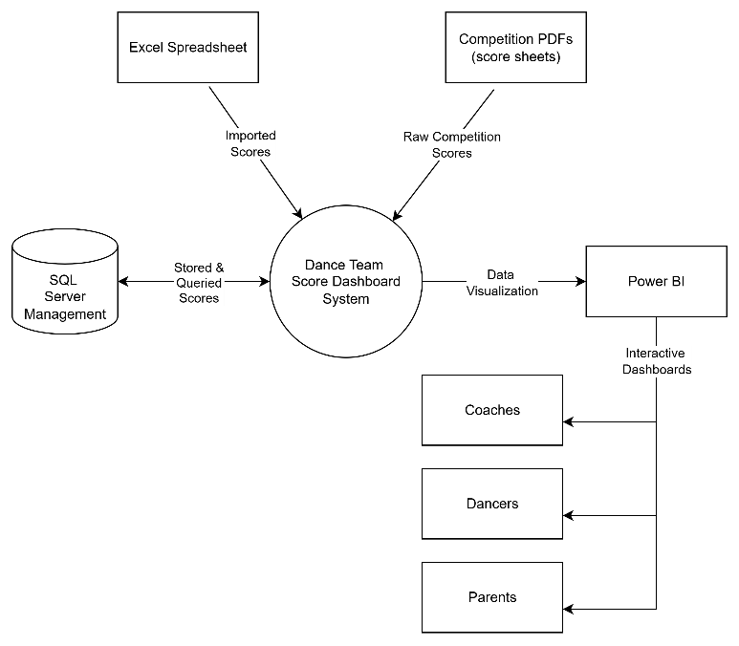
Shows data flow from PDF → Excel → SQL Server → Tableau

Figure 1. Context Diagram illustrating the data flow from raw PDFs to the final Tableau dashboard.
Figure 2. Wireframe
Mock layout of dashboard visuals and filter system

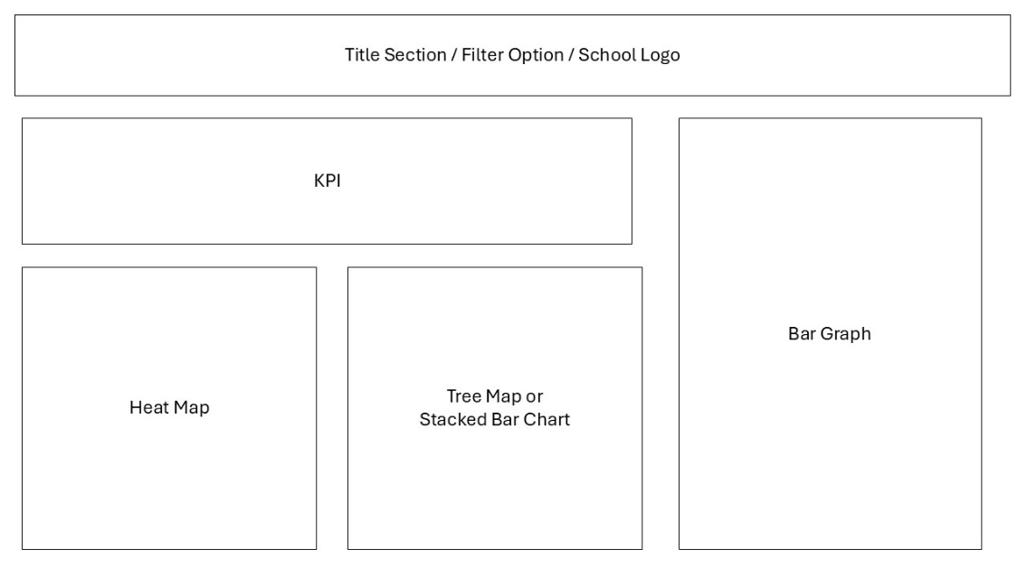

Figure 2. Wireframe showing the planned layout and filter options for the dashboard.

Technical Workflow
All raw data will be stored in Excel and cross-checked against competition PDFs. The data will be cleaned in SQL Server Management Studio to remove nulls and irrelevant values. Cleaned data will be structured into tables and views based on filters such as style and season.
These views will be imported into Tableau Public, where visuals will be built in separate sheets. This modular approach allows for individual tweaking and visual evaluation before assembling the final dashboard (Steven, 2020). Once complete, the dashboard will be published publicly for user access.

Project Constraints
The project will be completed using free applications, which limit access to advanced tools. Tableau Public restricts some customization and direct SQL imports, requiring a CSV as an intermediary. Despite these constraints, the timeline and resources are sufficient to meet project goals.

Methodology
The project follows an agile methodology with weekly sprints. This allows for flexibility and iterative refinement (White, 2008). Coaches will review the dashboard during development, providing feedback to improve usability and ensure the dashboard meets user needs. Combined with professor feedback, this approach supports a successful and responsive final product

GANNT Template
I downloaded the GANNT Template and will use it to outline my work from week to week. As I am following the agile method every week, I will fill out the GANNT Template after I evaluate what will need to be down and within what timeframe dependent on the weekly schedule. This will help me track where I am with my project.

Analysis Phase

Roles and Responsibilities
The roles and responsibilities outlined in this project reflect the key tasks that need to be evaluated, created, and implemented to ensure success. Although this is a solo project, each role represents a distinct mindset and set of responsibilities that I am fulfilling throughout the development process. The following table provides an overview of these roles and how they contribute to the planning, analysis, design, and delivery of the dashboard.
Table 1. Roles and Responsibilities
Role | Responsibility
Project Manager | Defines the project plan, creates the GANNT template, and delegates tasks across roles. Also serves as the documentation lead, updating project artifacts based on progress.
Business Analyst | Analyzes dashboard requirements based on the needs of coaches, dancers, and parents. Outlines key features and evaluates the current business process.
Data Engineer | Prepares raw data in Excel, cleans and structures data using SQL Server Management Studio, and creates tables and views aligned with end-user needs for Tableau integration.
Developer | Builds the Tableau dashboard, designs visuals based on user requirements, and transforms SQL views into clear, engaging data stories.
Project Stakeholders | Represent coaches, dancers, and parents. Evaluate whether the dashboard meets user needs and provide feedback for improvement.
Testers | Tests the dashboard across platforms. Verifies drill-down and filtering functionality, identifies faults, and recommends areas for refinement.

Table 1. Summarizes roles and responsibilities for each working person.

Work Structure Breakdown:

Project Manager
- Create Gantt chart template
- Delegate tasks across roles
- Update project documentation
- Check in with all working parts
- Review and finalize all documents

Business Analyst
- Create user journey table
- Draft functional and non-functional requirements table
- Build traceability matrix

Data Engineer
- Insert raw data into Excel, creating separate sheets for each season
- Transfer data into SQL Server Management Studio and create dance scores database
- Create separate Jazz and Kick tables
- Build tables for average total score and average category score
- Convert all tables into views
- Export results as CSV files for Tableau

Developer
- Create wireframe for dashboard layout
- Build bar graph visual for total scores
- Design heat map visual for category scores
- Develop KPI visuals for key performance indicators

Project Stakeholders
- Evaluating needs of coaches, dancers, and parents
- Review dashboard to ensure it meets user requirements
- Collaborate with developers to refine wireframes and visuals

Testers
- Test filtering functionality
- Test drill-down navigation
- Evaluate readability and accessibility
- Test dashboard across multiple platforms

Use Case Journey
The table below outlines the journey of a coach interacting with the dashboard, highlighting key goals, actions, and touchpoints. I chose to focus on the coach as the primary user, since their role involves analyzing scores and planning practices based on performance data. While dancers may use the dashboard in a similar way, they are more likely to apply the insights personally rather than for team strategy. Parents, on the other hand, may use the dashboard primarily to visually understand the components of competition scoring.
Table 2. Coach Use Case Journey
Phase | Phase 1:  Investigate | Phase 2:  Filter | Phase 3:  Analyze | Phase 4:  Decide | Phase 5:  Share
Goal | Review jazz competition scores. | Focus on jazz competition scores from the 2024-2025 season. | Determine the lowest scoring category on average in the 2024-2025 season. | Plan improvements for upcoming season. | Communicate with the team the lowest category on average in 2025.
Action | Open the jazz Tableau Public Dashboard | Use filter panels to narrow down to the 2024-2025 season. | Review Heat Maps and KPIs to find the weak areas. | Write down the low scoring areas to create a practice plan. | Verbal summary and pulling up visuals based on year and category.
Touch Point | Tableau Public | Filter Toggle | Visualizations | Visualizations | Visualizations

Table 2. Works through the coach’s user journey when interacting with the dashboard.

Functional Requirements
The table below outlines what the dashboard should do to meet the needs of its users. These functional requirements describe the key features and interactions that the dashboard should support, including what users should be able to see, filter, and explore. Each requirement reflects the goals and behaviors of the end-user population as identified in the user journey and analysis (Yoo, 2024). The features were selected to ensure the dashboard supports performance review, personal insight, and visual understanding across all user types.
Table 3. Functional Requirements
FReqID | Requirement | Description
FR1 | Database should be created in SQL Server Management | Data should be cleaned, structured, and stored in an SQL database.
FR2 | Dashboard should contain SQL queried views | Visuals should reflect the database and views created through SQL.
FR3 | Dashboard should display average scores | Users should be able to view average scores across categories and competitions.
FR4 | Dashboard should allow filter by season | Users should be able to filter average scores by competition season (e.g., 2024–2025).
FR5 | Dashboard should allow filter by category | Users should be able to filter average scores by category in the heatmap (e.g., Avg. Creativity).
FR6 | Dashboard should support drill-down view | Users should be able to explore specific competitions by location, date, and type.
FR7 | Dashboard should include visualizations | Users should be able to view heatmaps, KPIs, bar graphs, and tables.
FR8 | Dashboard should use color coordination | Visuals should be color-coded by school for clarity and comparison.
FR9 | Dashboard should accurately depict data to visual | Visual elements should match the underlying data in size, proportion, and comparison.

Table 3. Lists out and describes all functional requirements for the dashboard.

Non-functional Requirements
The table below outlines the non-functional requirements of the dashboard, focusing on how the system should operate to support user experience (Yoo, 2024). These requirements ensure the dashboard is reliable, usable, and performant across different devices and viewing conditions. They also highlight how the dashboard and SQL database work together to deliver accurate, responsive, and up-to-date data for end users.
Table 4. Non-functional Requirements
NFReqID | Requirement | Description
NFR2 | Dashboard should be publicly accessible | Users should not need login credentials to view the dashboard.
NFR2 | Dashboard should support multiple viewers | It should handle concurrent access without performance issues.
NFR3 | Dashboard should reflect live SQL views | It should update automatically based on changes in the SQL database.
NFR4 | Dashboard should be optimized for performance | SQL queries and dashboard logic should be efficient to ensure fast load times.
NFR5 | Dashboard should maintain performance | It should load quickly, even during drill-down filtering.
NFR6 | Dashboard should be responsive | It should adjust layout based on device or screen size.
NFR7 | Dashboard should calculate averages correctly | It should sum scores and output accurate averages per category.

Table 4. Lists out and describes all nonfunctional requirements for the dashboard.

Traceability Matrix
The traceability matrix below outlines the requirements listed in both the functional and non-functional requirements tables; each linked to a corresponding test case and testing plan. This matrix was created in Excel, where a dropdown menu will later indicate whether each test has passed or failed during the testing phase. It provides a clear overview of the tasks assigned to the data engineer, developer, and testers, while also informing the project manager, business analyst, and stakeholders of what will be implemented and evaluated throughout the project (Yoo, 2024).
Table 5. Traceability Matrix
Requirements |  | Testing
ReqID | Requirement | Type | TestCaseID | Test Description | Status
FR1 | Database should be created in SQL Server Management | Functional | TC1 | Run SQL database and verify structure and data integrity | Not Tested
FR2 | Dashboard should contain SQL queried views | Functional | TC2 | Execute SQL views and confirm data is available in Tableau | Not Tested
FR3 | Dashboard should display average scores | Functional | TC3 | Review dashboard visuals for correct average score display | Not Tested
FR4 | Dashboard should allow filter by season | Functional | TC4 | Apply season filter on bar graph and verify results | Not Tested
FR5 | Dashboard should allow filter by category | Functional | TC5 | Apply category filter on heatmap and verify results | Not Tested
FR6 | Dashboard should support drill-down view | Functional | TC6 | Test drill-down functionality by season year and competition | Not Tested
FR7 | Dashboard should include visualizations | Functional | TC7 | Compare dashboard visuals to documented requirements | Not Tested
FR8 | Dashboard should use color coordination | Functional | TC8 | Open dashboard and verify school color consistency | Not Tested
FR9 | Dashboard should accurately depict data to visual | Functional | TC9 | Compare visuals to stakeholder expectations and data values | Not Tested
NFR1 | Dashboard should be publicly accessible | Nonfunctional | TC10 | Open dashboard via public link without login | Not Tested
NFR2 | Dashboard should support multiple viewers | Nonfunctional | TC11 | Access dashboard from multiple devices simultaneously | Not Tested
NFR3 | Dashboard should reflect live SQL views | Nonfunctional | TC12 | Confirm dashboard updates with changes in SQL views | Not Tested
NFR4 | Dashboard should be optimized for performance | Nonfunctional | TC13 | Apply multiple filters and assess load time | Not Tested
NFR5 | Dashboard should maintain performance | Nonfunctional | TC14 | Refresh dashboard repeatedly and monitor responsiveness | Not Tested
NFR6 | Dashboard should be responsive | Nonfunctional | TC15 | Test dashboard layout on various devices | Not Tested
NFR7 | Dashboard should calculate averages correctly | Nonfunctional | TC16 | Compare dashboard averages to SQL query results | Not Tested

Table 5. Combines functional and nonfunctional requirements in a traceability matrix including test case and test method.

Design Phase

Technical Architecture
The database DanceScores in SQL Server Management contains all scores, tables, and views. The tables are broken down by style and year, while the views are condensed versions filtered by average scores. I used SQL queries to extract the information I felt was most useful and relevant to users omitting total scores, since they can be inconsistent depending on the number of judges at a competition. These views serve as the data source for the Tableau dashboard (Burback, n.d.).

Database Tables
- 22_21_Jazz
- 23_22_Jazz
- 24_23_Jazz
- 25_24_Jazz
- 22_21_Kick
- 23_22_Kick
- 24_23_Kick
- 25_24_Kick

Database Views
- Jazz_AvgScore_By_Competition
- Jazz_AvgScore_Categories
- Kick_AvgScore_By_Competition
- Kick_AvgScore_Categories

Entity Relationship Diagram
The diagram below illustrates the relationship between the base tables and the views. I extracted only the most relevant fields from each table to declutter the layout and improve visibility and understanding. A one-to-many relationship is used, as each table contains multiple rows that are aggregated or referenced within the views (Al-Fedaghi, 2021).
Figure 3. Entity Relationship Diagrams
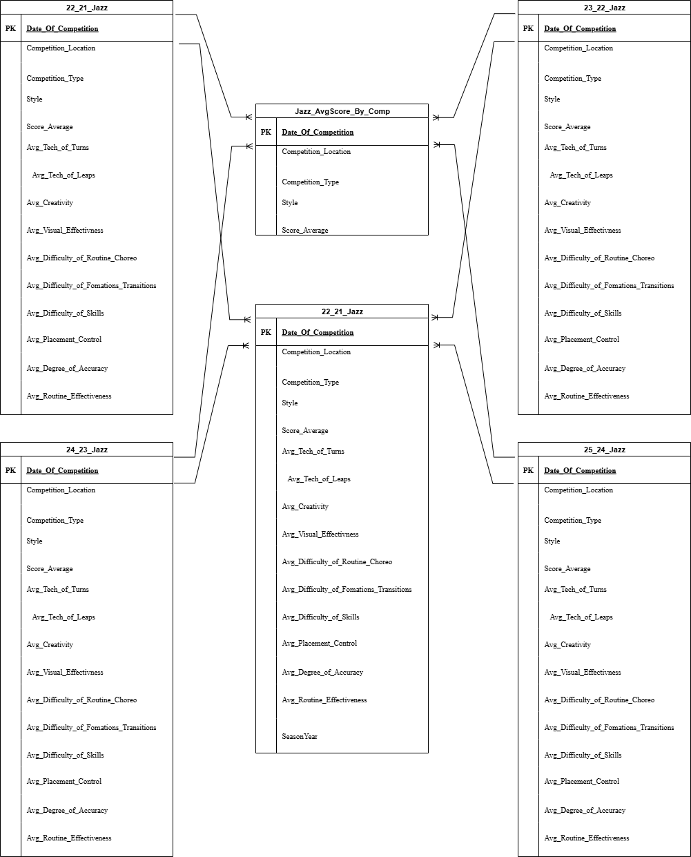
Figure 3 illustrates the relationship between the tables and views inside the database.

Data Dictionary
The data dictionary below highlights the field names that are specifically included in my views. This helps condense the table to the most important data points and emphasizes the ones used in building the Tableau dashboard. The database tables include both total scores and average scores, but since the dashboard focuses on average scores due to discrepancies across competitions, I’ve included only the average data points here. This choice improves user experience by providing consistent, comparable visuals across seasons and competitions.
Table 6. Data Dictionary
Field Name | Type | Description
Date_of_Competition | Integer | This is the primary key unique to each competition
Competition_Location | Varchar | This is the school's town name where the competition is held.
Competition_Type | Varchar | This identifies the type of competition. Labeled by Show, Invite, Conference, Sections, and State
Style | Varchar | This identifies the style kick or jazz
Total_Score | Integer | Total score for each competition.
Number_of_Judges | Integer | Number of judges at each competition.
Score_Average | Integer | Average score for each competition calculated from judges scores.
Avg_Tech_of_Turns | Integer | Average turn technique score, calculated by dividing total score by number of judges.
Avg_Tech_of_Leaps | Integer | Average jump technique score, calculated by dividing total score by number of judges.
Avg_Creativity | Integer | Average creativity score, calculated by dividing total score by number of judges.
Avg_Visual_Effectivness | Integer | Average visual effectiveness score, calculated by dividing total score by number of judges.
Avg_Difficulty_of_Routine_Choreo | Integer | Average difficulty of routine choreography score, calculated by dividing total score by number of judges.
Avg_Difficulty_of_Fomations_Transitions | Integer | Average formations and transitions score, calculated by dividing total score by number of judges.
Avg_Difficulty_of_Skills | Integer | Average difficulty of skills score, calculated by dividing total score by number of judges.
Avg_Placement_Control | Integer | Average placement and control score, calculated by dividing total score by number of judges.
Avg_Degree_of_Accuracy | Integer | Average degree of accuracy score, calculated by dividing total score by number of judges.
Avg_Routine_Effectiveness | Integer | Average routine effectiveness score, calculated by dividing total score by number of judges.
Avg_Tech_Of_Kicks | Integer | Average kick technique score, calculated by dividing total score by number of judges.
Avg_Kick_Height | Integer | Average kick height score, calculated by dividing total score by number of judges.
Avg_Difficulty_Of_Kicks | Integer | Average difficulty of kicks score, calculated by dividing total score by number of judges.
Season_Year | Integer | This is a field broken down into year.
Table 6 includes all the data fields used within the database views that support the Tableau dashboards.

Use Case Alignment
The technical architecture, entity relationship diagram, and data dictionary connect directly to the use case created during the analysis phase. These design phase elements tell the story and structure behind the coach’s journey through the dashboard system. The tables and diagrams developed this week provide backend insight into how the data is organized, filtered, and surfaced to support that experience.

Dashboard Structure
The structure of the Tableau dashboard will include appropriate visuals for each data point. There will be four dashboards: Jazz Overview, Jazz Breakdown, Kick Overview, and Kick Breakdown. All dashboards will be linked together for seamless navigation.
The overview dashboards will display visuals broken down by season. Each will include two KPIs: one showing the highest scoring competition and one showing the lowest. Bar charts will display the overall average score for each season. A heat map will show the average score for each category across seasons. A tree map will visualize category hierarchy in the order used during scoring.
The breakdown dashboards will include two tables: one showing each competition and its average score, and one showing each competition with a breakdown of average scores by category. These dashboards contain a large amount of data and allow users to filter by season for deeper analysis.
A cover page may be added to the dashboard to help use readability and understanding. This page would give an overview of the dashboard and navigation section to help users navigate to the appropriate dashboard.

Wireframes
The figures below illustrate the structural layout of the Becker Dance Team dashboard. A blue color scheme is used to represent Becker High School branding. Each figure maps out the placement of key visuals, including score summaries, category breakdowns, and seasonal trends. Filter locations and navigation links are clearly indicated to support intuitive drill-down functionality and cross-dashboard navigation. This layout supports both Jazz and Kick styles, with Overview and Drill-Down dashboards connected.
Figure 4. Jazz Overview Wireframe
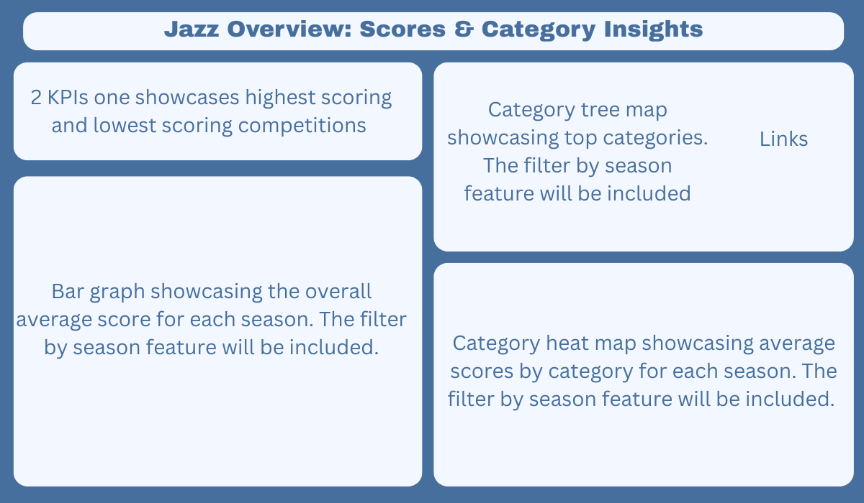
Figure 4 illustrates the layout of the jazz overview dashboard page.
Figure 5. Jazz Drill-Down Wireframe
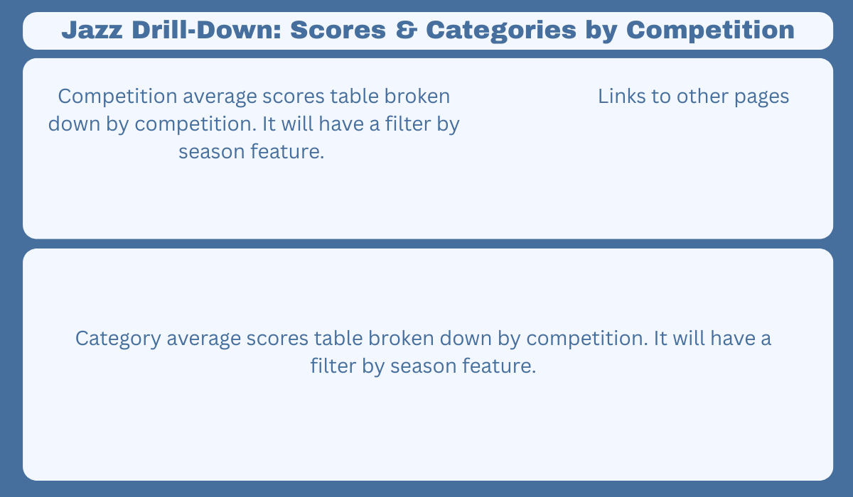
Figure 5 illustrates the layout of the jazz drill-down dashboard page.
Figure 6. Kick Overview Wireframe
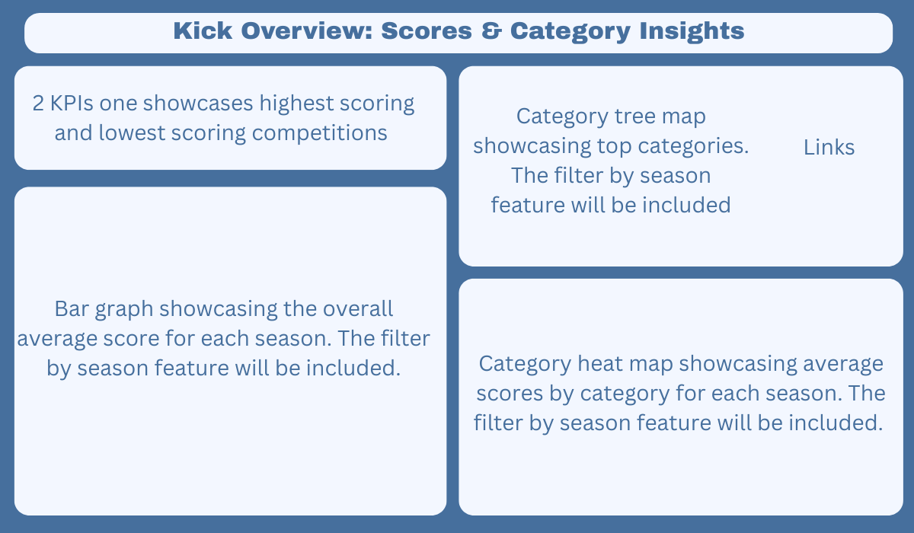
Figure 6 illustrates the layout of the kick overview dashboard page.
Figure 7. Kick Drill-Down Wireframe
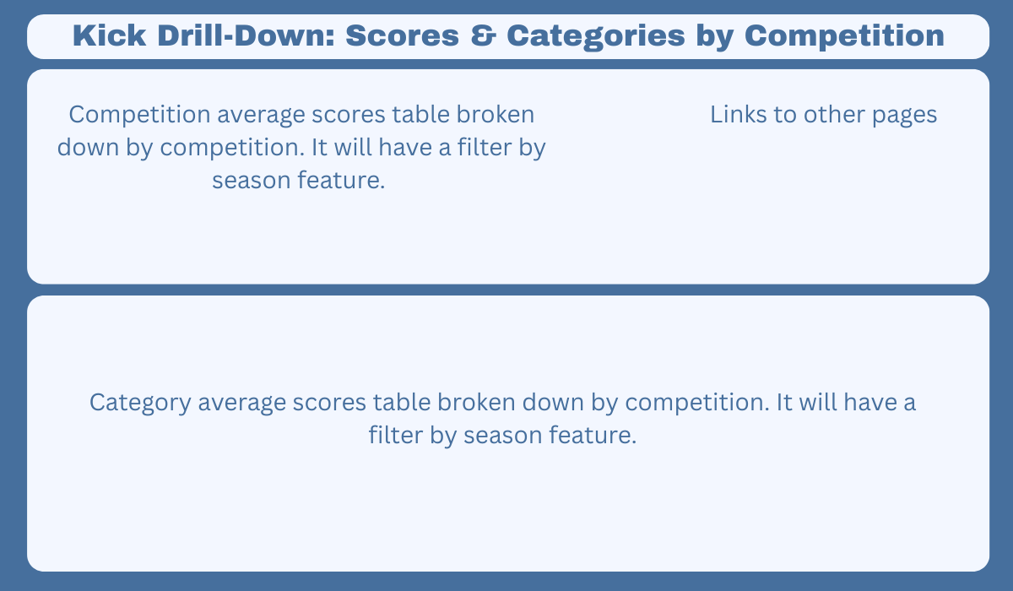
Figure 7 illustrates the layout of the kick drill-down dashboard page.

Design Alignment

The technical design of this project is directly aligned with the user needs identified during the analysis phase. The database structure, views, and dashboard logic were all shaped by the coach’s use case journey. Each table and view was intentionally built to support specific user actions, such as filtering by style, comparing average scores across competitions, and identifying areas for improvement. By focusing on calculated averages instead of total scores, the design ensures consistency and fairness, especially when the number of judges varies between events. This alignment between backend structure and user experience helps create a dashboard that is both intuitive and actionable.

Ethical Considerations

Throughout the design process, I made intentional choices to prioritize fairness, clarity, and data integrity. One key decision was to exclude total scores from the views, recognizing that they can be misleading due to inconsistencies in judging panels. By focusing on average scores, the dashboard promotes a more equitable comparison across competitions. I also ensured that the data presented is anonymized and does not expose any personal or sensitive information about individual dancers or judges. The goal is to empower users, especially coaches and parents, with insights that are accurate, respectful, and useful, without compromising privacy or fairness.

Development Phase

Set Up Process
Applications Used:
- Google Sheets – Stores the raw data each year for the Becker Dance Team.
- Excel – Used to organize and separate raw scores by year before importing into SQL Server Management Studio.
- Microsoft SQL Server Management Studio – Used to transform, clean, and structure the data. Views were created here to support Tableau integration.
- Tableau – Used to build interactive visuals and dashboards based on the cleaned data.
- Canva – Used to design the background visuals for the dashboard interface.

Data Preparation
I used Microsoft SQL Server Management Studio to clean the data and create views. All of the data provided to me were totals from the allotted number of judges at each competition. This made things a bit tricky, since you can't apply a blanket mathematical calculation when there's a discrepancy between five judges and seven judges.
To address this, I used Excel to calculate averages based on the number of judges. This step made the process of creating views in SQL much easier. While it could be argued that I could have built all the views in Excel, I chose to use SQL to showcase my skills and demonstrate a more scalable approach.

Cleaning and Updating
The first step was to assign the Date_of_Competition column as non-null because I wanted to use it as the primary key. I chose this field because it was unique to each year and competition, whereas locations can be similar from year to year. Once non-null values were enforced, I assigned Date_of_Competition as the primary key for each table (Siggard, 2022).
Next, I calculated average scores and category metrics. Since the original data provided totals based on a varying number of judges, I used Excel to calculate accurate averages before creating views in SQL Server Management. This ensured consistency across all tables.
Below are code snippets from the cleaning process. To keep the document concise, not all tables and years are shown.
Code Snippet 1. Enforcing no null dates
alter table [25_24_Jazz] alter column Date_of_Competition date not null;
Date_of_Competition date not null;

code snippet 1. All Jazz and Kick tables were updated to enforce non-null values for Date_of_Competition.
Code Snippet 2. Assigning Primary Key
alter table [25_24_Jazz] add constraint PK_25_24_Jazz primary key (Date_of_Competition);

Code Snippet 2. Each table was assigned a primary key using Date_of_Competition to uniquely identify competition records.
Code Snippet 3. Rounding Averages
update [25_24_Jazz] set Score_Average = round(Score_Average, 2);
update [25_24_Jazz] set Avg_Tech_of_Leaps = round(Avg_Tech_of_Leaps, 2);
update [25_24_Kick] set Avg_Kick_Height = round(Avg_Kick_Height, 2);

Code Snippet 3. All average score fields across Jazz and Kick tables were rounded to two decimal places for cleaner presentation.

Average Score By Competition Views
I created an average score view for both Kick and Jazz styles. This view included the date of competition, location, type, style, and score average. I ordered the view by date of competition so that the results displayed in chronological order.
This view was designed to support my bar graphs, which depict score averages for each season, as well as my drill-down page that displays all average scores for each competition across the four years (Siggard, 2022)
Below are code snippets for the Jazz and Kick score views, followed by screenshots of the resulting visuals.
Code Snippet 4. Jazz Average Score View
create Jazz_AvgScore_By_Comp as
select Date_of_Competition, Competition_Location, Competition_Type, Style, Score_Average
from [25_24_Jazz]
union all
select * from Jazz_AvgScore_By_Comp order by Date_of_Competition;
Code Snippet 4. The view contains score averages by consolidating all Jazz tables across the four competition years.
Code Snippet 5. Kick Average Score View
create view Kick_AvgScore_By_Comp as
select Date_of_Competition, Competition_Location, Competition_Type, Style, Score_Average
from [25_24_Kick]
union all
select * from Kick_AvgScore_By_Comp order by Date_of_Competition;
Code Snippet 5. The view contains score averages by consolidating all Kick tables across the four competition years.
Figure 8. Jazz_AvgScore_By_Comp (Left) and Kick_AvgScore_By_Comp (Right) Views
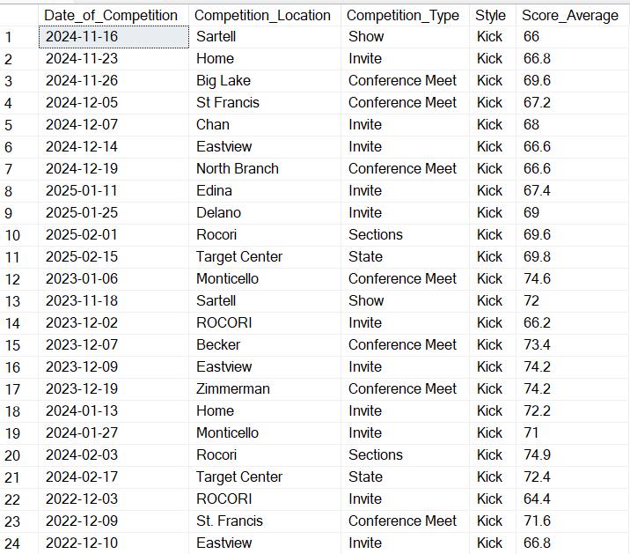
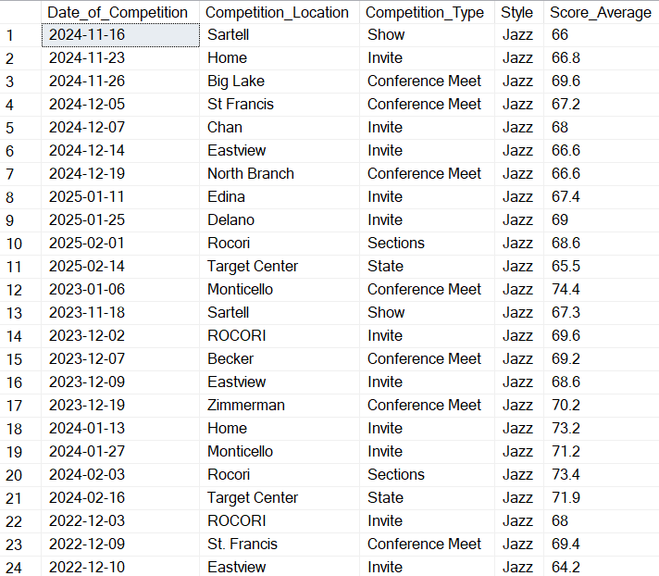

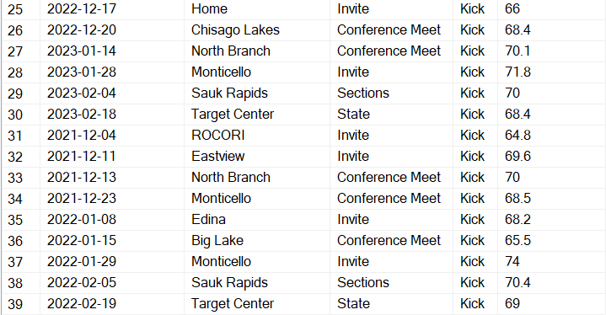
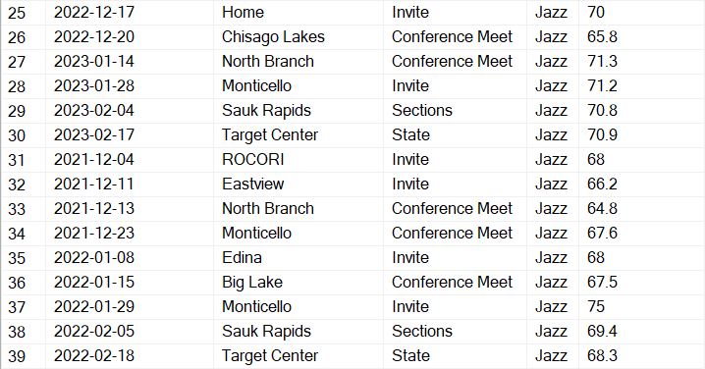

Figure 8. Jazz (left) and Kick (right) Average Score Views showing competition averages across all years.

Average Scores By Categories and Competition
I created views for the average scores by category for both Kick and Jazz. This view included all of the categories that teams are scored on. Since these are two different styles, the categories differ in the technique area, as each style contains distinct technical skills.
These views were used in the heat map to compare category scores across seasons on the overview page. They were also used on the drill-down page to display all category scores for each competition.
Below are the code snippets for the view. I ordered the results by Date_Of_Competition to display them in chronological order.
Code Snippet 6. Jazz Average Category Scores View
create view Jazz_AvgScore_Categories as
select Date_of_Competition, Competition_Location, Competition_Type, Avg_Tech_of_Turns, Avg_Tech_of_Leaps, Avg_Creativity, Avg_Visual_Effectivness, Avg_Difficulty_of_Routine_Choreo, Avg_Difficulty_of_Fomations_Transitions, Avg_Difficulty_of_Skills, Avg_Placement_Control, Avg_Degree_of_Accuracy, Avg_Routine_Effectiveness
from [25_24_Jazz]
union all
select * from Jazz_AvgScore_Categories order by Date_Of_Competition;

Code Snippet 6. The view contains category averages by consolidating all Jazz tables across the four competition years
Code Snippet 7. Kick Average Category Scores View
create view Kick_AvgScore_Categories as
select Date_of_Competition, Competition_Location, Competition_Type, Avg_Tech_of_Kicks,
Avg_Kick_Height, Avg_Creativity, Avg_Visual_Effectivness, Avg_Difficulty_of_Routine_Choreo, Avg_Difficulty_of_Fomations_Transitions, Avg_Difficulty_of_Kicks, Avg_Placement_Control, Avg_Degree_of_Accuracy, Avg_Routine_Effectiveness
from [25_24_Kick]
union all
select * from Kick_AvgScore_Categories order by Date_of_Competition;
Code Snippet 7. The view contains category averages by consolidating all Kick tables across the four competition years
After creating the views and inserting them into Tableau, I went back and added a Season column to each view. This allowed me to filter competitions by season within the dashboard. I used a CASE statement to group competitions based on season years. This was implemented for both Kick and Jazz views (Siggard, 2022).
Code Snippet 8. Added Season Year Column
case
when Date_of_Competition between '2021-11-1' and '2022-3-1' then '2021-2022'
when Date_of_Competition between '2022-11-1' and '2023-3-1' then '2022-2023'
when Date_of_Competition between '2023-11-1' and '2024-3-1' then '2023-2024'
when Date_of_Competition between '2024-11-1' and '2025-3-1' then '2024-2025'
else 'Unknown'
end as SeasonYear
Code Snippet 8. Added Season Year column to help filtering in Tableau.
Figure 9a. Jazz_AvgScore_Categories View – first 8 columns
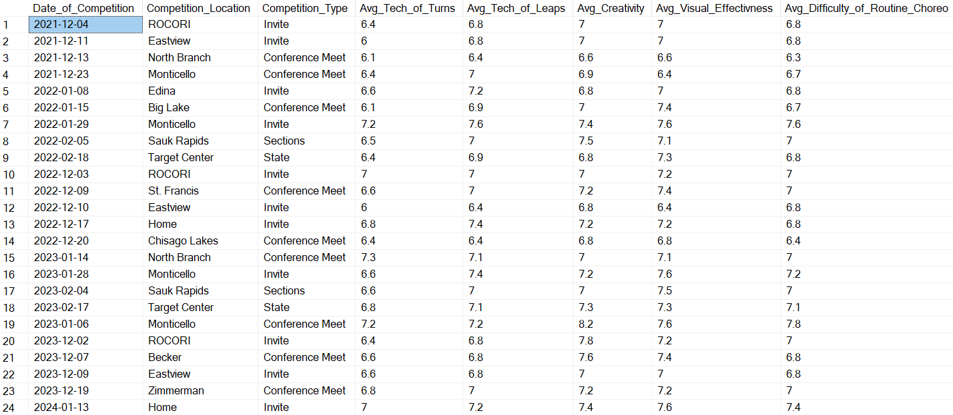
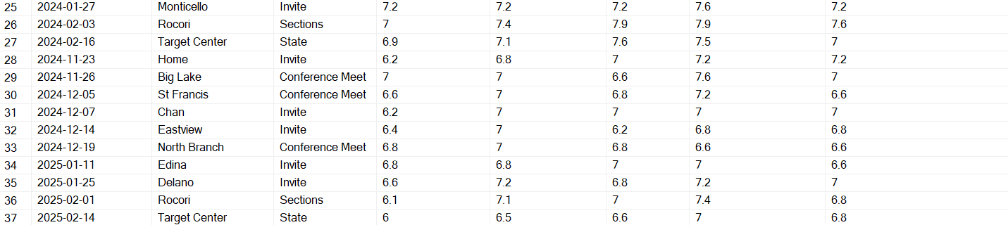

Figure 9a. Includes the first 8 category columns created within the Jazz view.
Figure 9b. Jazz_AvgScore_Categories View – last 6 columns
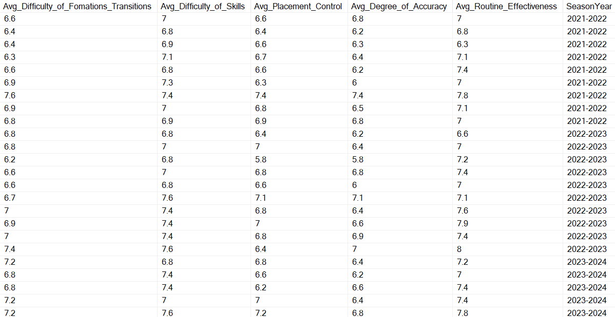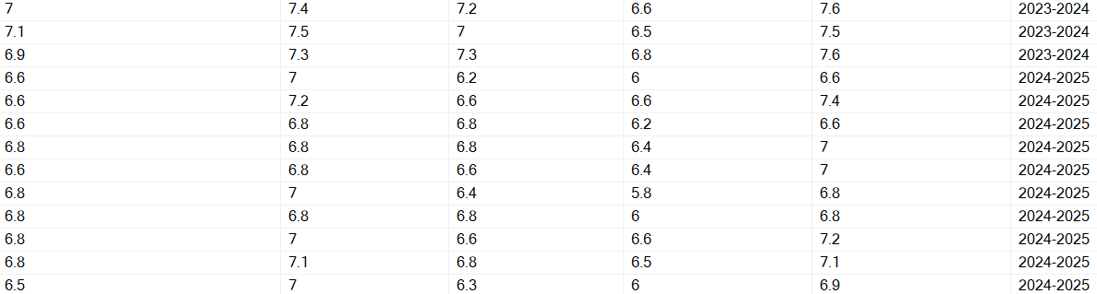
Figure 9b. Includes the last 6 category columns created within the Jazz view.
Figure 10a. Kick_AvgScore_Categories View – first 8 columns
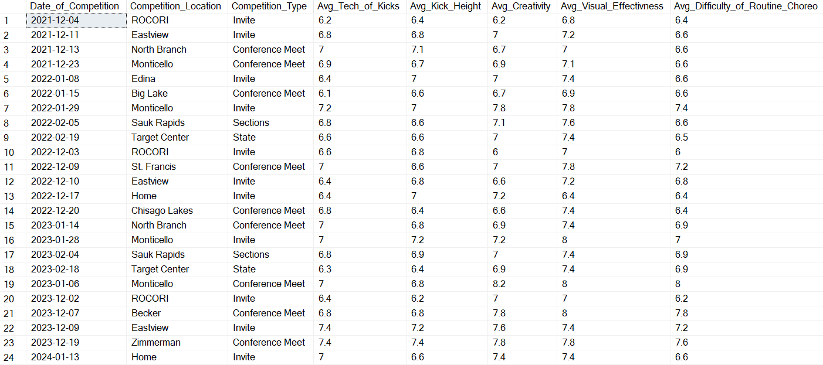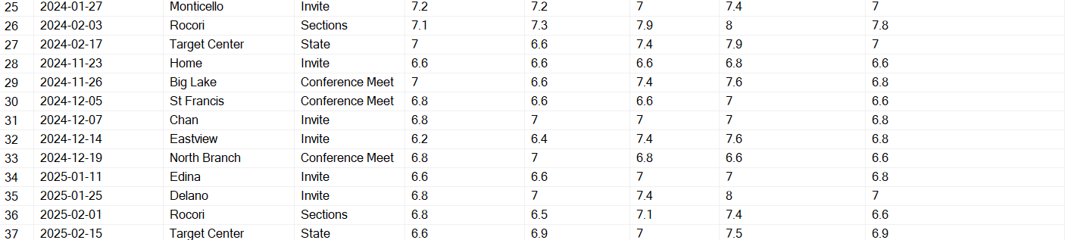

Figure 10a. Includes the first 8 category columns created within the Kick view.
Figure 10b. Kick_AvgScore_Categories View – last 6 columns
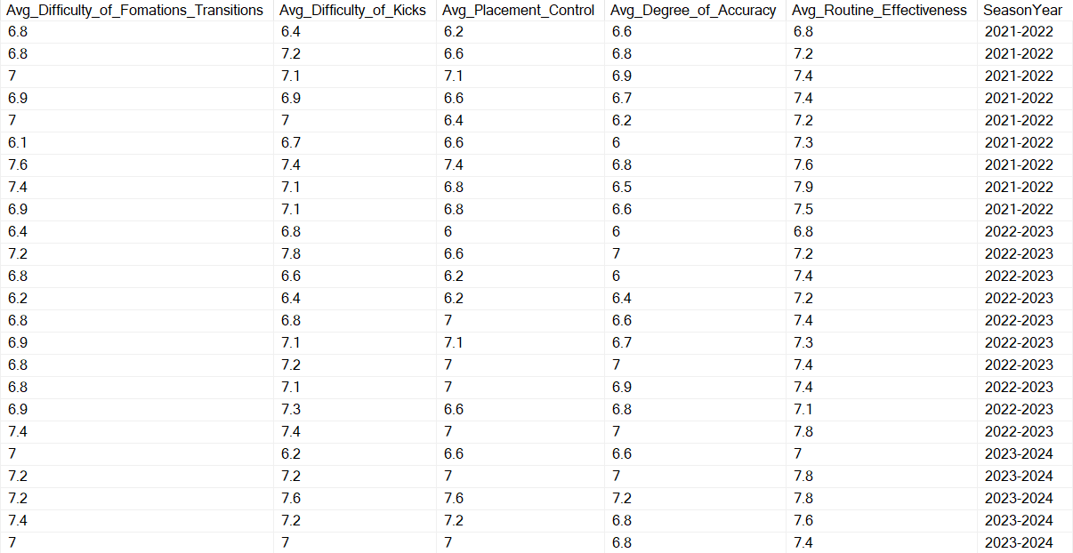

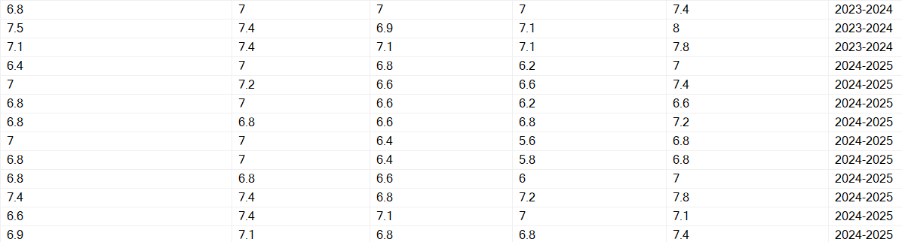

Figure 9b. Includes the last 6 category columns created within the Kick view.

Dashboard Development
I created background wireframes in Canva to maintain a cohesive visual theme across dashboards and to incorporate team colors. I designed a main cover page to introduce the dashboard and provide context for what it delivers.
The dashboard includes a Jazz and Kick overview page, which displays season average scores. I also created drill-down dashboards for both Jazz and Kick, where average scores are broken down by competition across all four seasons (Meyer, 2022).

Home Page

When laying out all of the dashboards, I wanted to send a clear message about what the dashboard represents and the purpose behind it. To do this, I created a home page that introduces the project and connects all of the dashboards in one place — similar to the navigation structure of a website. This home page includes an overview explanation and the school logo to reinforce the dashboard’s identity and audience. Below is a screenshot of the home page.
Figure 11. Home Page
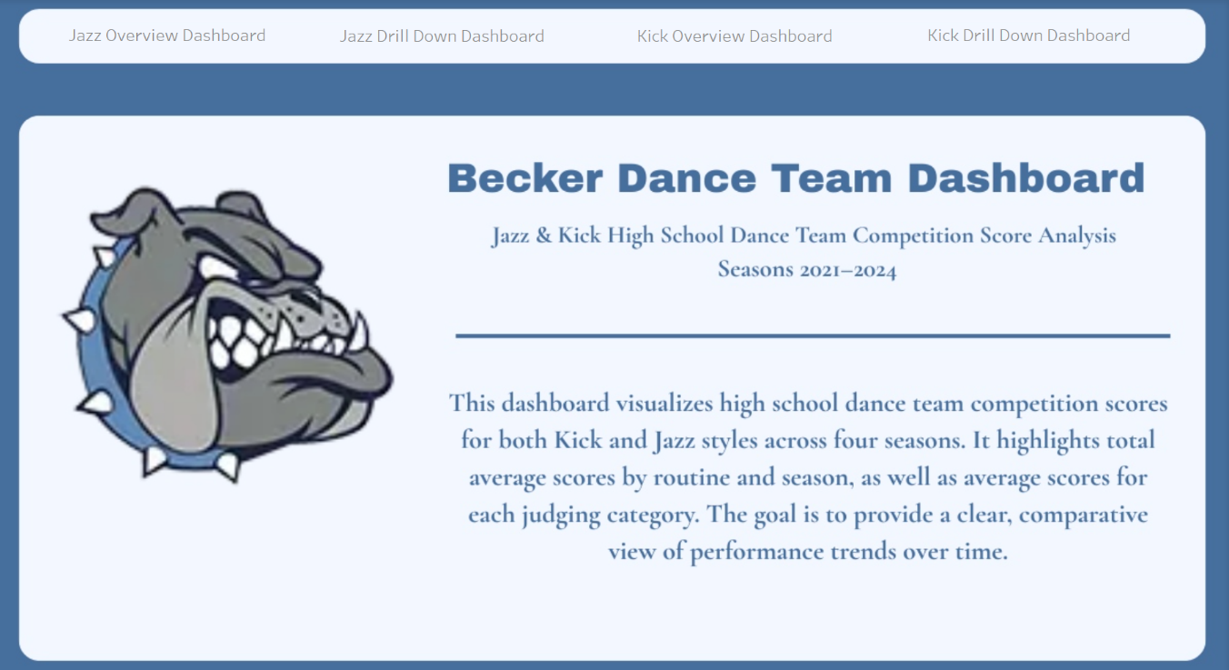
Figure 11. The home page displays its purpose and links to other dashboards.

Jazz & Kick Overview Dashboards
The Jazz and Kick overview dashboards display total average scores for each season year. They include key performance indicators (KPIs) to highlight the highest and lowest scoring competitions. I used a bar graph, heat map, tree map, and two KPIs to visualize these trends. Navigation buttons were added to each side of the dashboard to support seamless movement between views. The purpose of the overview dashboards was to give quick insights on the averages for all four seasons. This allows for comparison in total score and categories (Meyer, 2022). Below are screenshots for both the kick and jazz overview Dashboards.
Figure 12. Jazz (right) & Kick (left) Overview Dashboards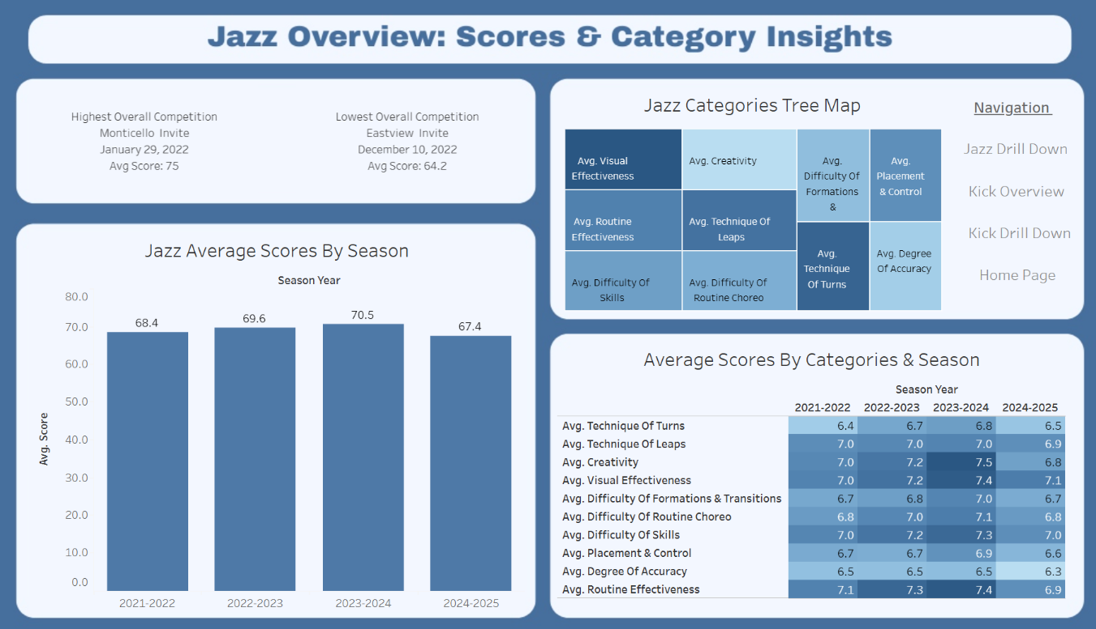
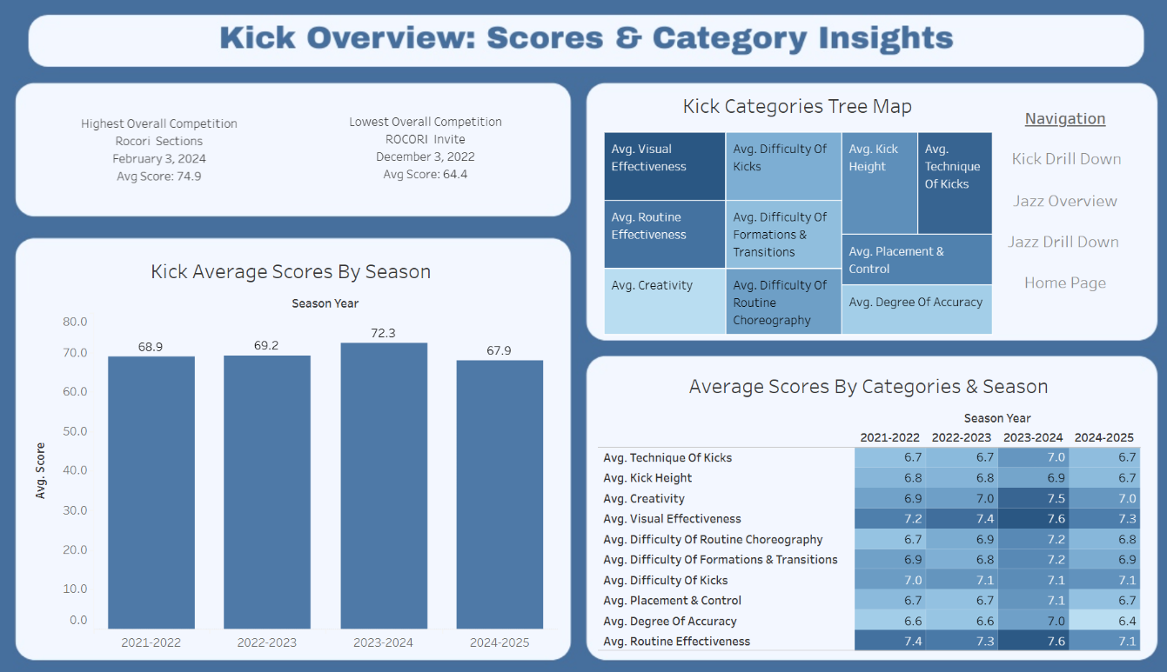
Figure 12. Depicts the Jazz & Kick overview dashboards.

Jazz & Kick Average Scores Bar Graphs
To create the bar graph, I used the Jazz_AvgScore_By_Comp and Kick_AvgScore_By_Comp views. In the marks card I applied a Season Year filter and placed Season Year in the columns, with Average Score in both the rows and the text label. This setup allowed me to display overall average scores from all competitions in a single, consolidated graph.
Below is a screenshot of the resulting bar graph.
Figure 13. Jazz (right) & Kick (left) Average Bar Graphs
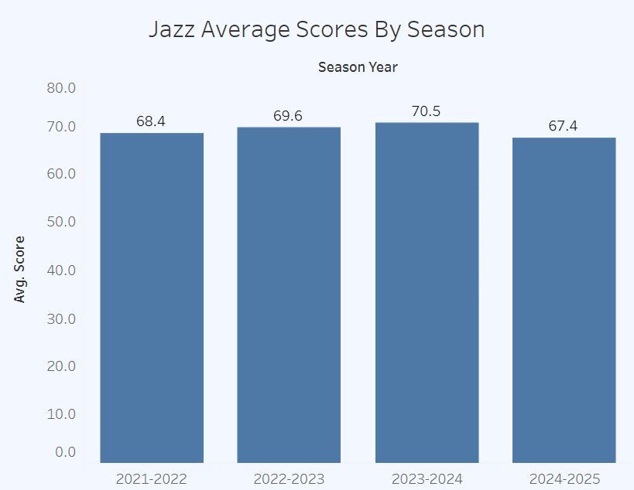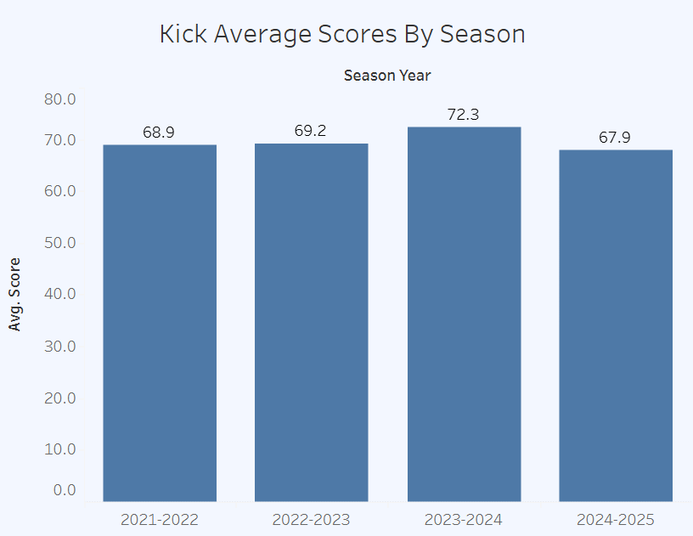
Figure 12. The bar graphs depict the average scores by season.

Jazz & Kick Average Scores By Categories Heat Maps
I used the Jazz_AvgScore_Categories and Kick_AvgScore_Categories views to create the heat map. I applied a Season Year filter to connect all visuals across the dashboard and placed it in the columns. In the marks card I used Measure Values to group all scoring categories into a single container, averaging the values for each category. These averages were added to both the Text and Color elements, allowing the color intensity to reflect the score values.
To display the names of each category, I dragged Measure Names into the rows. I chose a heat map because it provides a clear, visual comparison of high and low scoring categories across many categories, making patterns and outliers easy to identify.
Figure 14. Jazz (right) & Kick (left) Categories Heat Map
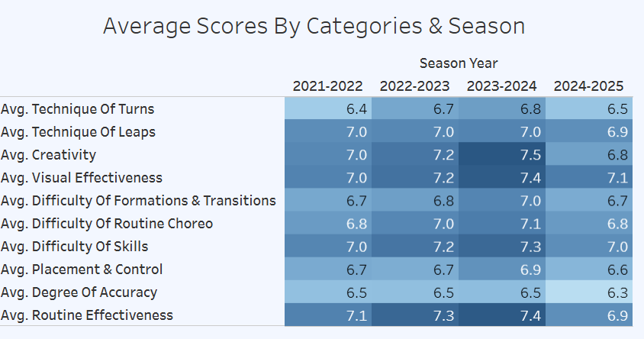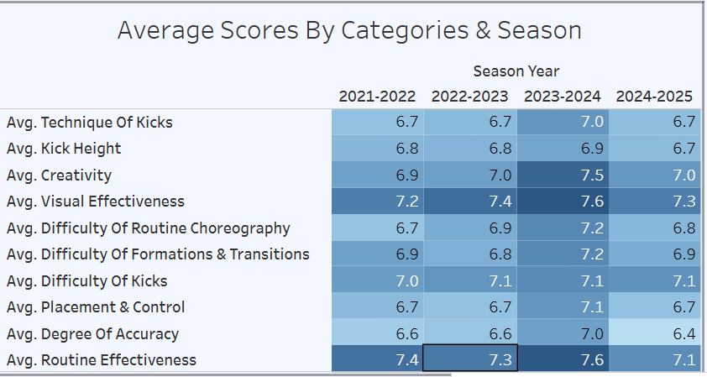
Figure 13. The heat maps depict the average scores by category and season.

Jazz & Kick Tree Maps
To create the tree maps, I used the Jazz_AvgScore_Categories and Kick_AvgScore_Categories views. I knew I was building a visual to highlight the highest and lowest scoring competitions, and I wanted to showcase category-level performance in a similar way.
In the marks card I used Measure Names and Measure Values for all elements within the tree maps. Measure Names were used for the Color and Text elements, while Measure Values were used for Detail and Size. This setup allowed each category to be visually represented by both its score and its relative weight, making it easy to compare performance across categories.
Figure 15. Jazz (right) & Kick (left) Tree Maps
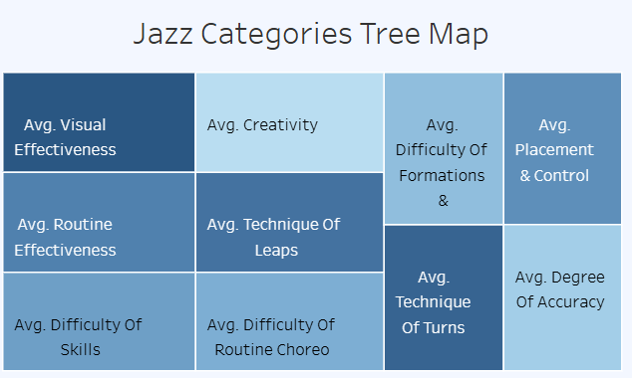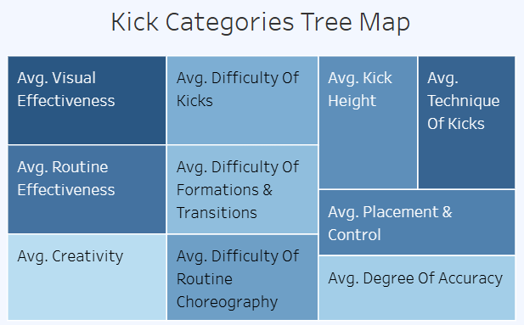
Figure 15. The Tree Maps depict the different scoring categories in hierarchal order.

Jazz & Kick Highest and Lowest Scoring Competitions KPI
I added a KPI to my dashboard to showcase the highest and lowest scoring competitions across the seasons for both Jazz and Kick. When users initially open the dashboard, they see the highest and lowest scoring competitions overall. The intention behind this was to provide a clear snapshot of performance — highlighting which day stood out and prompting users to ask, “What happened here?” or “Where did we score highest on that day?” From there, they can navigate to the drill-down page to explore the details. Not all calculated fields were created specifically for each dance style, as most variables were designed to be consistent across both.
Figure 15. Jazz (right) & Kick (left) Highest and Lowest Scoring Competitions KPI
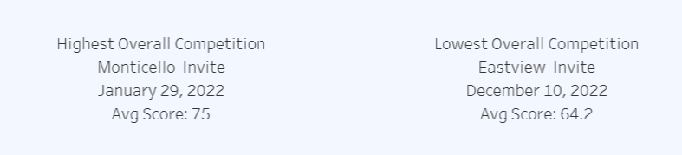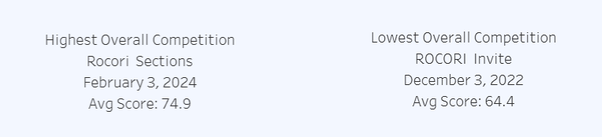
Figure 15. Displays the highest and lowest scoring competitions for Jazz & Kick.
To highlight the highest and lowest scoring competitions, I had to create multiple calculated fields. Since Tableau doesn’t allow mixing aggregated and non-aggregated values within the same calculation, I needed separate fields for both overall competitions and season-specific competitions. I began by extracting the maximum and minimum average scores for both the overall dataset and each season. The Max Avg and Min Avg calculated fields return the highest and lowest average scores across all seasons, regardless of filters. In contrast, the Max Avg Season and Min Avg Season fields return the highest and lowest average scores based on the selected season filter
Code Snippet 9a. Max & Min Avg Calculated Field
{ FIXED : MAX([Avg Score]) }
{ FIXED : MIN([Avg Score]) }
Code Snippet 9a. It is the calculated field for finding the max & min avg score overall.
Code Snippet 9b. Max & Min Avg Season Calculated Field
{ FIXED [Season Year] : MAX([Avg Score]) }
{ FIXED [Season Year] : MIN([Avg Score]) }
Code Snippet 9b. It is the calculated field for finding the max avg score for the season filter.
Next, I created Boolean calculated fields to validate the highest and lowest scoring competitions. The Max & Min Avg – Boolean fields check whether the Avg Score equals either the overall Max Avg or Min Avg, identifying the competitions with the highest and lowest average scores across all seasons. I also created a separate set of Boolean fields, Max & Min Avg Season – Boolean, which apply the same logic but are scoped specifically to the selected season filter for drill-down analysis.
Code Snippet 10a. Max & Min Avg – Boolean Calculated Field
[Avg Score] = [Max Avg]
[Avg Score] = [Min Avg]
Code Snippet 10a. Creates a Boolean for the max & min avg overall score.
Code Snippet 10b. Max & Min Avg Season – Boolean Calculated Field
[Avg Score] = [Max Avg Season]
[Avg Score] = [Min Avg Season]
Code Snippet 10b. Creates a Boolean for the max & min avg season overall score.
The next calculated fields I created were the Max Overall and Min Overall fields. These used the Boolean logic to identify the highest and lowest scoring competitions, then pulled in additional details — including the date of competition, location, type, and score — to display as KPI cards. I also rounded the average score in these fields to improve visual clarity. To support season-specific drilldowns, I created separate fields: Max Overall Season and Min Overall Season, which use the season-based Boolean logic. As with previous logic, the structure for minimum averages mirrors that of the maximum averages, with only the comparison values switched.
Code Snippet 11a. Max Avg Overall Calculated Field
IF [Max Avg - Boolean] THEN
"Highest Overall Competition" + CHAR(10)
+ [Location] + " " + [Comp Type] + CHAR(10)
+ DATENAME('month', [Date Of Competition]) + " "
+ STR(DAY([Date Of Competition])) + ", "
+ STR(YEAR([Date Of Competition])) + CHAR(10)
+ "Avg Score: " + LEFT(STR(ROUND([Avg Score], 1)), FIND(STR(ROUND([Avg Score], 1)) + ".", ".") + 1)
END
Code Snippet 11a. Creates the label for the KPI for the max avg overall score.
Code Snippet 11b. Max Overall Season Calculated Field
IF [Max Avg Season - Boolean] THEN
"Highest Scoring Competition" + CHAR(10)
+ [Location] + " " + [Comp Type] + CHAR(10)
+ DATENAME('month', [Date Of Competition]) + " "
+ STR(DAY([Date Of Competition])) + ", "
+ STR(YEAR([Date Of Competition])) + CHAR(10)
+ "Avg Score: " + LEFT(STR(ROUND([Avg Score], 1)), FIND(STR(ROUND([Avg Score], 1)) + ".", ".") + 1)
END
Code Snippet 11a. Creates the label for the KPI for the max avg season overall score.
The final calculated fields I created were Highest Jazz Score, Lowest Jazz Score, Highest Kick Score, and Lowest Kick Score. These fields consolidate the logic from previous calculations and display the corresponding highest or lowest score, depending on whether a season filter is applied. The Highest Jazz Score field, shown below, pulls the top score for Jazz and is placed in a text element alongside the selected season year from the filters pane. The Kick and lowest score fields follow a similar structure, using the same logic adapted for style and high verses low.
Code Snippet 12. Highest Jazz Score Calculated Field
IF COUNTD([Season Year]) > 1 THEN
ATTR([Max Overall])
ELSE
ATTR([Max Overall Season])
END
Code Snippet 12. Displays the corresponding max avg score for the filter and overall feature.

Jazz & Kick Drill Down Dashboards
The Jazz and Kick Drill Down Dashboards display average scores for all dance competitions across four seasons. Each dashboard includes two separate tables: one showing the total average score for each competition, and another breaking down averages by judging category. These dashboards also feature seamless navigation, allowing users to move easily between views. Additional details such as competition date and location are included to provide full context (Meyer, 2022). Below are screenshots of both dashboards.
Figure 16. Jazz & Kick Drill Down Dashboards
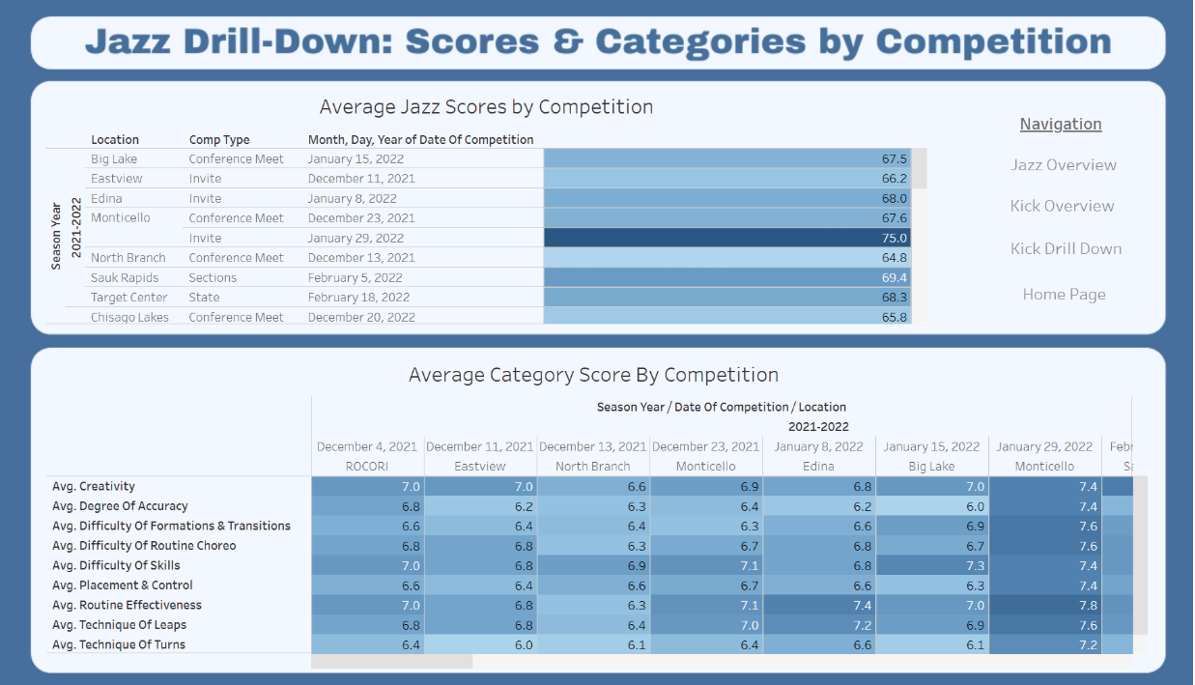
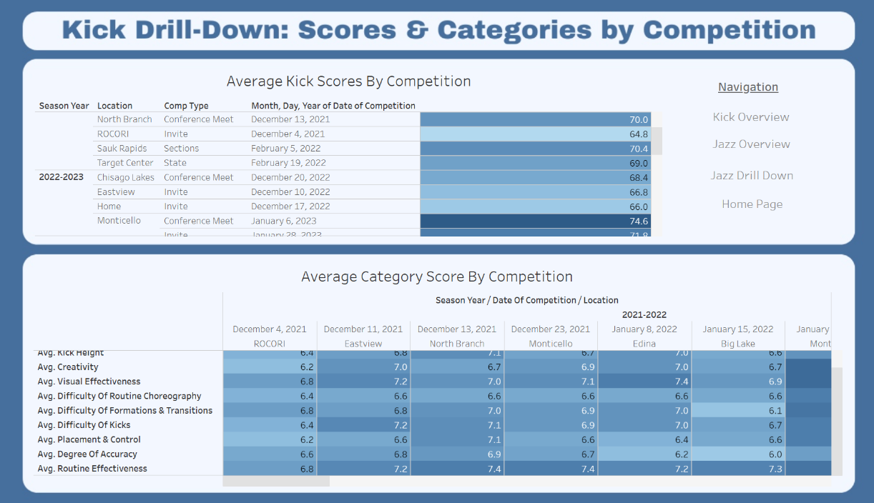
Figure 16. Depicts the Jazz & Kick drill down dashboards.

Jazz & Kick Average Scores By Competition Tables
I used the Jazz_AvgScore_By_Comp and Kick_AvgScore_By_Comp views to create tables displaying average scores for each competition. In the Rows shelf, I included Season Year, Location, Comp Type, and Date of Competition to provide full context. For the Marks card, I applied Avg Score to both the color and text elements, allowing users to visually distinguish higher and lower scoring competitions through the color gradient. This approach helps highlight performance trends at a glance. Below are screenshots of each table.
Figure 17. Jazz & Kick Average Scores by Competition Tables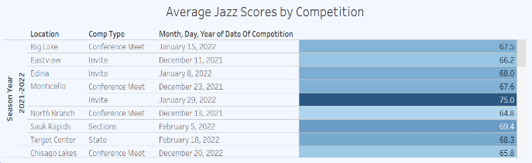
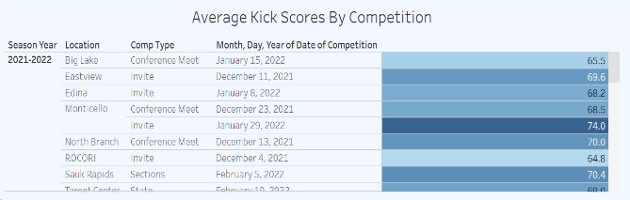
Figure 17. Depicts the average scores by competition for jazz and kick.

Jazz & Kick Average Scores by Category and Competition
I used the Jazz_AvgScore_Categories and Kick_AvgScore_Categories views to create tables displaying average scores for each judging category at each competition. In the Columns shelf, I included Season Year, Date of Competition, and Location to provide context. In the Rows shelf, I used Measure Names to list each judging category. On the Marks card, I applied Measure Values to both the text and color elements, using the same color system as the total score averages to visually highlight performance across categories. Below are screenshots of each table.
Figure 18. Jazz & Kick Average Category Scores by Competition Tables
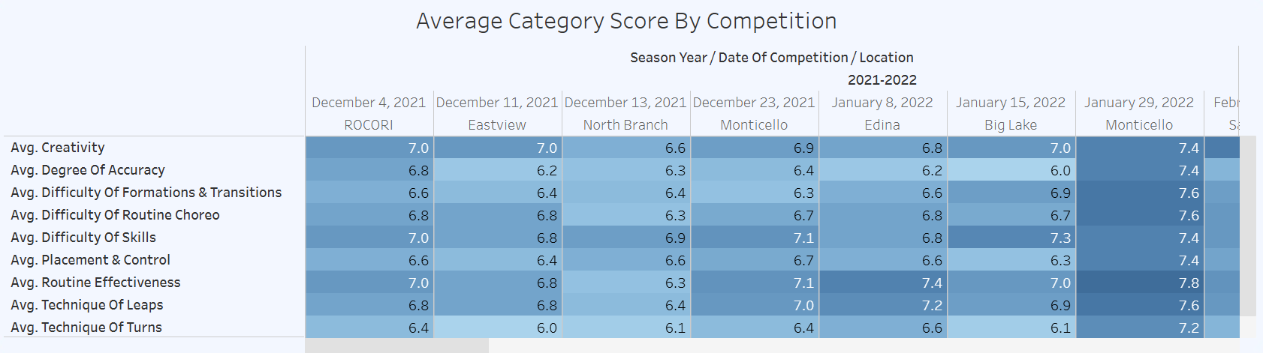
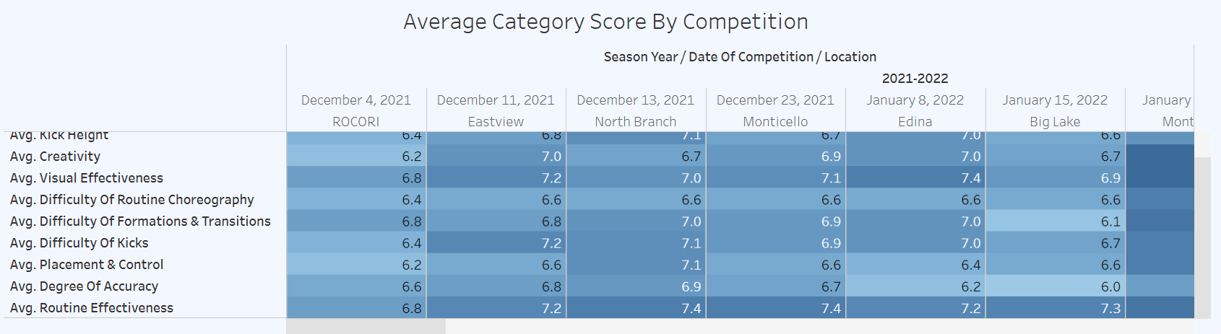
Figure 18. Depicts the average score categories by competition for jazz and kick.

Technical Architecture and Software Quality
The technical architecture of my dashboard separates data management from presentation. All data cleaning and structuring is handled in Microsoft SQL Server, while Tableau is used solely for visualization. This separation enhances both the user experience and the maintainability of the dashboard.
- Usability: I created clear navigation buttons to help users move between dashboards. Each dashboard is labeled to indicate the style (Kick or Jazz) and the type of scores being displayed, making it easy for users to understand what they’re viewing.
- Scalability: Storing and managing data in Microsoft SQL Server allows for new season scores to be added easily. These updates can be reflected in the dashboard by extending the existing views.
- Accessibility: A consistent color scheme, clear labeling, and appropriate visual choices (e.g., bar graphs, heat maps) help users interpret the data quickly and accurately.
- Reliability: Tableau provides a stable platform for visualizations, ensuring that the user experience remains consistent across sessions.
- Availability: The dashboard is viewable online and will be deployed publicly, making it accessible to coaches, dancers, and parents from any location.

Testing Phase
To validate the dashboard against project requirements, I followed a structured testing strategy using the traceability matrix developed during the analysis phase. I expanded the matrix to include test documentation, changes made, and second-round results to capture iterative improvements. Testing included manual walkthroughs of use case scenarios, device responsiveness checks using Tableau’s preview tools, and feedback from external reviewers. Their insights led to refinements in KPI logic, layout clarity, and filter behavior. All failed test cases were resolved and retested to ensure the dashboard met its functional goals and was ready for release.

Validate Use Case Journey
In the original use case journey, I specified that a coach should be able to open the Tableau dashboard, review jazz scores, and identify the lowest scoring category for the 2024–2025 season to aid in making a practice plan. During testing, this scenario was validated successfully. When navigating to the Jazz Overview dashboard page, the heat map in the upper-right corner displays category averages by season. Upon selecting the 2024–2025 season, the lowest scoring category is Degree of Accuracy and is clearly indicated both numerically and visually. The corresponding cell is the lightest shade on the heat map, signaling its status as the lowest average score. This visual cue, combined with the displayed score, confirms that the dashboard supports the coach’s decision-making process as intended. The figure below illustrates this validated interaction
Figure 19. Lowest Scoring Jazz Category 2024-2025 Season
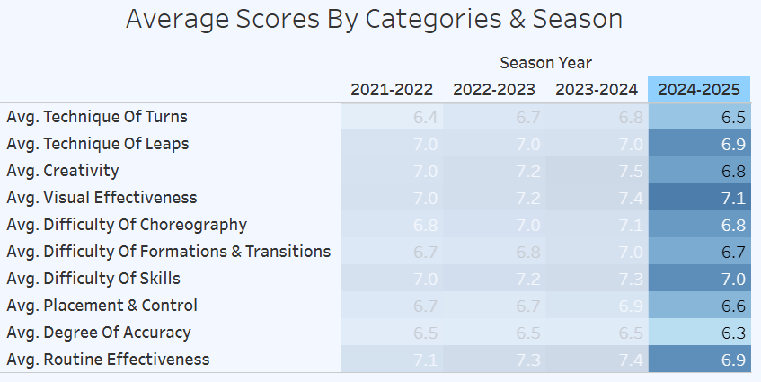
Figure 19. Highlights the 2024-2025 season and degree of accuracy is lowest scoring category.

Traceability matrix
The traceability matrix created during the analysis phase included a comprehensive set of test cases covering both functional and nonfunctional requirements. During the testing phase, I systematically walked through each test case and expanded the matrix to include additional columns for test documentation, changes made, and results from a second round of testing. Several issues were identified during initial testing phase, which prompted retesting across all cases to ensure accuracy and completeness. For clarity and focus, the requirements column has been excluded from the Testing section; please refer to Table 5 in the Analysis phase for the original requirement-to-test mapping.
Table 6. Traceability Matrix – Testing
Testing
Type | TestCaseID | Test Description | Test Documentation | Status | Changes Made | 2nd Test
Functional | TC1 | Run SQL database and verify structure and data integrity | Verified that the database structure and data integrity were accurate | Passed | N/A | Passed
Functional | TC2 | Execute SQL views and confirm data is available in Tableau | All SQL views contained accurate data and formatting. All views were successfully inserted into Tableau. | Passed | N/A | Passed
Functional | TC3 | Review dashboard visuals for correct average score display | The KPI visuals initially failed to accurately depict the highest and lowest scoring competitions. | Failed | Separated the calculated fields to improve Tableau’s ability to interpret and render the functions correctly. | Passed
Functional | TC4 | Apply season filter on bar graph and verify results | The KPI visuals were corrected to accurately display the highest and lowest scoring competitions. | Failed | Separated the calculated fields to improve Tableau’s ability to interpret and render the functions correctly. | Passed
Functional | TC5 | Apply category filter on heatmap and verify results | The category filter on the heatmap functioned as intended. | Passed | N/A | Passed
Functional | TC6 | Test drill-down functionality by season year and competition | The drill-down functionality by season year and competition worked as expected. | Passed | N/A | Passed
Functional | TC7 | Compare dashboard visuals to documented requirements | Dashboard visuals aligned with documented requirements. | Passed | N/A | Passed
Functional | TC8 | Open dashboard and verify school color consistency | The dashboard consistently displayed school colors across all pages. | Passed | N/A | Passed
Functional | TC9 | Compare visuals to stakeholder expectations and data values | Visuals met stakeholder expectations and matched underlying data values. | Passed | N/A | Passed
Nonfunctional | TC10 | Open dashboard via public link without login | The dashboard was successfully accessed by multiple users without requiring a Tableau account. | Passed | N/A | Passed
Nonfunctional | TC11 | Access dashboard from multiple devices simultaneously | The dashboard was opened simultaneously on two devices without issue. | Passed | N/A | Passed
Nonfunctional | TC12 | Confirm dashboard updates with changes in SQL views | The dashboard updated correctly when the data source was removed and reconnected. | Passed | N/A | Passed
Nonfunctional | TC13 | Apply multiple filters and assess load time | Load times were tested and found to be efficient. | Passed | N/A | Passed
Nonfunctional | TC14 | Refresh dashboard repeatedly and monitor responsiveness | Upon refresh, the dashboard’s response time was appropriate. | Passed | N/A | Passed
Nonfunctional | TC15 | Test dashboard layout on various devices | The dashboard was tested across multiple devices for layout and functionality. | Failed | The phone layout was omitted due to the dashboard’s content density and layout complexity, which exceeded the constraints of mobile screen dimensions. | Passed
Nonfunctional | TC16 | Compare dashboard averages to SQL query results | All average values displayed in the dashboard were compared to SQL query results and found to be accurate. | Passed | N/A | Passed

Table 6. Documents the testing phase of the traceability matrix.

Testing Failures and Fixes
While working through the traceability matrix, I encountered two major issues that were identified, addressed, and resolved. After implementing the necessary fixes for each failed test case, I conducted a second round of testing to confirm that the issues were fully resolved. These updates were documented directly within the traceability matrix. I also verified that no regressions occurred, ensuring that the fixes did not negatively impact other parts of the dashboard.

Test Case 3 & 4 – KPI Validation
Issue:
While testing the highest and lowest scoring competition KPIs, I cross-checked the results against the drill-down competition page and identified a discrepancy. The KPI was only evaluating the first competition of each season rather than scanning all available scores. As a result, it failed to accurately display the true highest and lowest scoring competitions.
Fix:
Upon reviewing the calculated fields, I found that although the logic was technically valid, Tableau struggled to process the deeply nested functions within a single field. To resolve this, I broke the logic into multiple smaller calculated fields:
- One field to isolate the highest and lowest scores.
- A second to retrieve contextual information (e.g., competition name, season).
- A third to apply a Boolean check for active filters.
- A final field to compile and output the correct values.
This modular approach improved Tableau’s ability to interpret the logic and display the correct KPI values.
Retesting:
After implementing the fix, I retested the KPI functionality across all filters. I paid special attention to scenarios where multiple seasons were selected simultaneously, ensuring the correct competitions were still identified. I cross-validated the results with the drill-down page and confirmed that the KPIs now reflected accurate, filter-responsive values. Once verified, I committed the changes.

Test Case 15 – Device Layouts
Issue:
Initially, I designed the dashboard using a customized default layout intended to render consistently across multiple devices. However, during testing on mobile phones, the layout proved unresponsive. The use of floating visuals and nested containers prevented the dashboard from adapting properly to smaller screen sizes, resulting in a poor user experience on mobile.
Fix:
To address the issue, I restructured the layout by reducing the number of floating objects and increasing the use of fixed containers. Despite these changes, the phone layout remained unreadable due to the volume and size of visuals—particularly on the overview page. I then explored Tableau’s dedicated phone layout feature, but the content density made it impossible to display all key visuals clearly on a mobile screen. As a result, the phone layout failed to meet the functional requirements for usability and completeness. After evaluating the trade-offs, I made a project decision to omit the phone layout from the initial release, prioritizing clarity and functionality on larger devices.
Retesting:
Following this decision, I retested the dashboard across multiple laptops and tablets to ensure layout consistency and responsiveness. I also shared the dashboard with users on different devices to confirm that the structured containers rendered correctly and the user experience remained intact.

User Feedback
To ensure the dashboard met user needs, I shared it with a coaching colleague for review. Her feedback was supportive—she found the layout intuitive and the overall process clean and well-structured. She also cross-checked the scores and visuals, confirming that all data was accurate and functioning properly. The only adjustment she recommended was on the drill-down pages, specifically within the categories section. At the time, users had to scroll both vertically and horizontally to view all categories and competitions, which made navigation cumbersome. Based on her suggestion, I revised the layout so that users now only need to scroll horizontally to view competitions, while all categories remain visible without vertical scrolling. This change improved readability and user experience. The figure below illustrates the updated layout.
Figure 20. Updated Drill-Down Category Visual
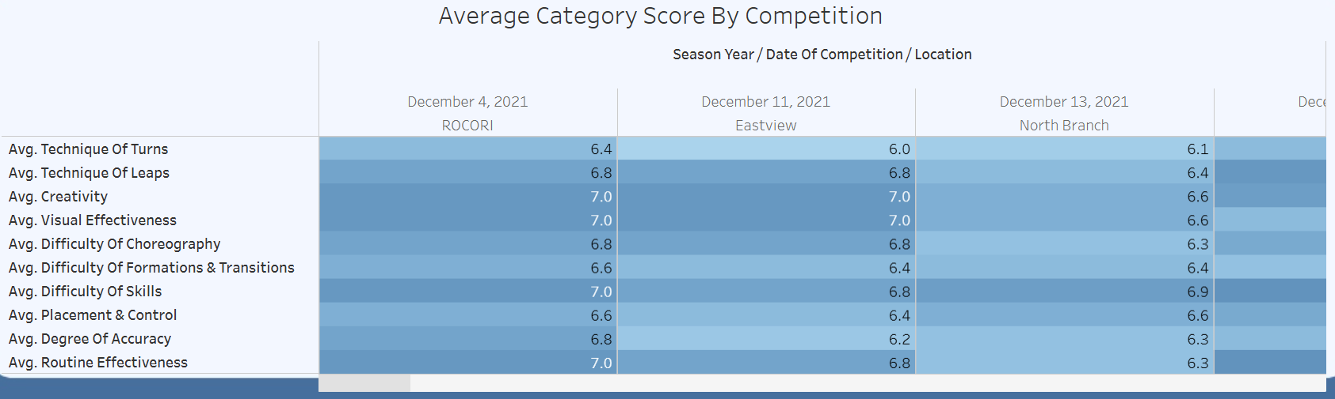
Figure 20. Represents the layout change so that all categories are visible.

Professional Feedback

To ensure my dashboard functioned at a professional level, I reached out to a mentor who works as a data analyst. Her feedback was positive overall, especially regarding functionality, but she offered valuable suggestions to improve user readability and understanding.
The first point she raised was about navigation consistency. Having the main navigation in different places across pages wasn’t ideal for users. I revisited my wireframe and redesigned the layout to feature a consistent top navigation bar, aligning it with the home page for a smoother user experience.
Her second suggestion focused on the tree map. She felt it wasn’t effective for conveying information clearly, and recommended switching to a horizontal bar chart. I made that change, which improved readability and comparison across categories.
Finally, she pointed out small details around label clarity. I cleaned up labels across all pages to ensure consistency and ease of interpretation.
I’ve applied all her suggestions throughout the dashboard. I’m including the Jazz Overview page as an example of these refinements.
Let me know if you’d like help writing a caption or annotation for the Jazz Overview page, or if you want to add a brief note about how these changes support your audience (e.g., dancers, coaches, parents). You’re doing a fantastic job balancing technical polish with user-centered design.
Figure 21. Updated Overview
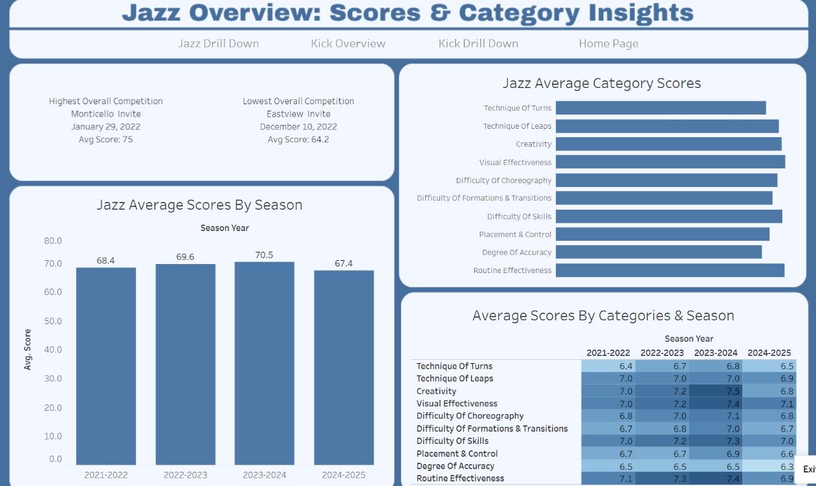
Figure 21. Includes the changes made after professional feedback.

Implementing and Maintenance

Distributing The System
After making the final changes, it was time to deploy the dashboard to a larger audience. I first shared it with the entire coaching staff, since they rely on performance data to guide their decisions. I also sent the dashboard to a select group of dancers, focusing on upperclassmen who I felt would benefit most from using it. Younger dancers, such as the 13-year-olds, were excluded from this initial rollout because I anticipated they might not find it as useful. In addition, I distributed the dashboard to booster club parents, as they were the easiest group to reach through established communication channels.
To support the rollout, I included detailed instructions in an email explaining how the dashboard works and outlining the requirements for the applications it can be viewed on. As I shared the link, I asked recipients to provide feedback and confirm that the dashboard was functioning as intended. This helped ensure that the system was not only accessible but also meeting the needs of its users.

User Documentation
To help users understand and navigate the dashboard, I provided clear instructions in the rollout email. The documentation explained the structure of the dashboards, how to use filters, and how to interpret the visuals.
Dashboard Overview
There are four dashboards, all connected through the navigation system:
- Overview Dashboards – Display season averages.
- Drill-Down Dashboards – Display averages broken down by competition.
How to Use the Overview Dashboards
- Select a season icon (e.g., “2023–2024”) to filter the visuals.
- View the horizontal bar graph labeled Jazz Average Category Scores.
  - This graph shows average scores overall and by season.
  - The bars adjust based on the year selected.
- Review the KPI box, which highlights the highest and lowest scoring competitions.
  - This KPI also filters by season.
- Explore the bar graph showing average score per judge (out of 100).
  - This graph is filterable by season year.
- Examine the heat map, which visually represents season averages.
- Darker colors indicate higher average scores.
- This visualization is also filterable by season and category scores.
How to Use the Drill-Down Dashboards
- Click on a competition or season to filter the visuals.
- Review the average scores per category.
- Check the average score per judge (out of 100).
Feedback Request
At the end of the email, I included the dashboard link and asked users to provide feedback. Specifically, I requested:
- Confirmation that the dashboard was viewable and functional.
- Thoughts on usability and clarity.
- Suggestions for changes or improvements.
I explained that while feedback would guide future updates, not all requests could be accommodated.

Training
Formal training was not required to use the dashboard because it was designed to be intuitive and supported by clear documentation. Before distributing the dashboard and email instructions, I talked through its features with the coaching staff. Although I did not provide a step-by-step visual demonstration, I explained the navigation, filters, and visuals verbally to ensure they understood how to use it. I also highlighted areas that I anticipated might cause confusion, so coaches would be prepared if those issues arose. This informal training helped build confidence in using the dashboard and reduced the likelihood of problems during the rollout.

Help Desk/ Support
In the email instructions, I explicitly told users to contact me by email if they encountered any issues with the dashboard. Since my audience is not at a large scale keeping it confined to email was the easiest choice. So far, I have not received any reports of problems from those who have accessed it. However, I anticipated that certain issues could arise, particularly related to formatting. Because formatting was a challenge during development, I recognized that users opening the dashboard on different laptop or computer monitor sizes might experience functionality differences. To prepare for this, I made sure to mention the potential issue when speaking with others, so they would be aware of it in advance. By establishing email communication as the primary support channel and proactively addressing possible concerns, I created a simple but effective help desk process to assist users as needed.

Monitoring and System Changes
After distributing the dashboard, I began checking it frequently to ensure that the data files were loading properly. A few days after deployment, I encountered an error with the data not loading as expected. Upon investigation, I discovered that the issue was related to the server rather than the data itself. Since then, I have made it a habit to monitor the system regularly to confirm that the dashboard continues to function correctly.
As the current season progresses and eventually concludes, I plan to add the new season’s data to the dashboard so that it remains up to date and useful for users. Because this project is a passion of mine, I am committed to gathering feedback and looking for ways to improve the system. Small adjustments, as well as more extensive updates such as developing a mobile-friendly layout, are changes I am considering for future iterations. By monitoring performance and planning for updates, I am ensuring that the dashboard remains flexible, reliable, and aligned with the needs of its users.

References
Al-Fedaghi, S. (2021, September 29). Conceptual Data Modeling: Entity-relationship models as thinging machines. arXiv.org. https://arxiv.org/abs/2109.14717
Benzarti, I., Mili, H., & Medeiros de Carvalho, R. (n.d.). Modeling and Personalising the Customer Journey: The Case for Case Management. https://www.researchgate.net/publication/355782842_Modeling_and_Personalising_the_Customer_Journey_The_Case_for_Case_Management
Burback, R. L. (n.d.). The design phase. The Design Phase. http://infolab.stanford.edu/~burback/watersluice/node11.html
Mănescu, D. C. (2025). Big Data Analytics Framework for Decision-Making in Sports Performance Optimization. Data, 10(7), 116. https://doi.org/10.3390/data10070116
Meyer, B. C., & Bishop, D. S. (2022). A Lesson in Tableau Dashboard Design: Playing the Beer Game with a Real-Time Data Connection. Decision Sciences Journal of Innovative Education, 20(4), 212–223. https://doi.org/10.1111/dsji.12264
Siggard, R., Dupin-Bryant, P. A., Mills, R. J., & Olsen, D. H. (2022). Teaching Tip: Using SQL to Create and Mine Large, Customizable Datasets. Journal of Information Systems Education, 33(3), 209–228.
Steven Batt, Tara Grealis, Oskar Harmon & Paul Tomolonis (2020) Learning Tableau: A data visualization tool, The Journal of Economic Education, 51:3-4, 317-328, DOI: 10.1080/00220485.2020.1804503
White, K. R. J. (2008). Agile project management: a mandate for the changing business environment. Paper presented at PMI® Global Congress 2008—North America, Denver, CO. Newtown Square, PA: Project Management Institute.
Yoo, I., Park, H., Lee, S.-W., & Ryu, K.-Y. (2024). Building Traceability Between Functional Requirements and Component Architecture Elements in Embedded Software Using Structured Features. Applied Sciences, 14(23), 10796. https://doi.org/10.3390/app142310796

